

SMALL OBERATING SYSTEM



kareem magdy albolaqi

sprint

10

Table of Contents

LAYERD ARCHTICTURE 2

CLASS DIGRAM 5

SEQUENCE DIGRAM 5

STATE MACHI 5

# LAYERD ARCHTICTURE

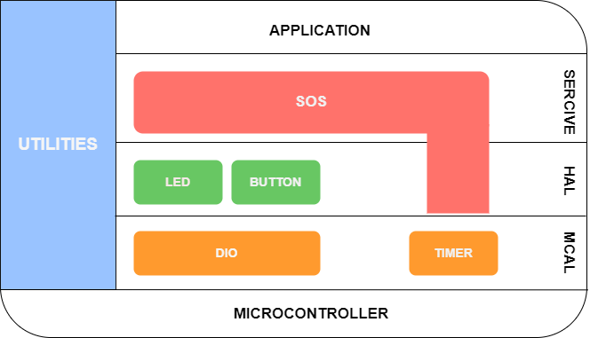

# CLASS DIGRAM

## 

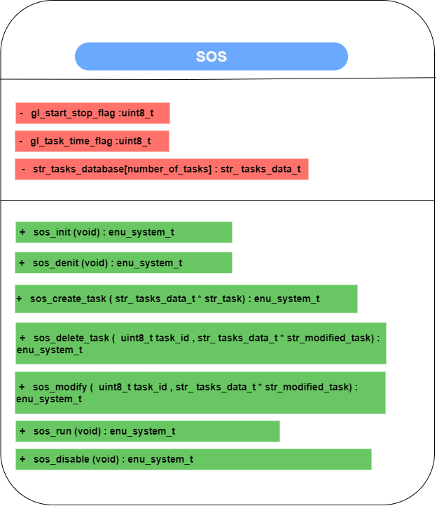

# SEQUENCE DIGRAM

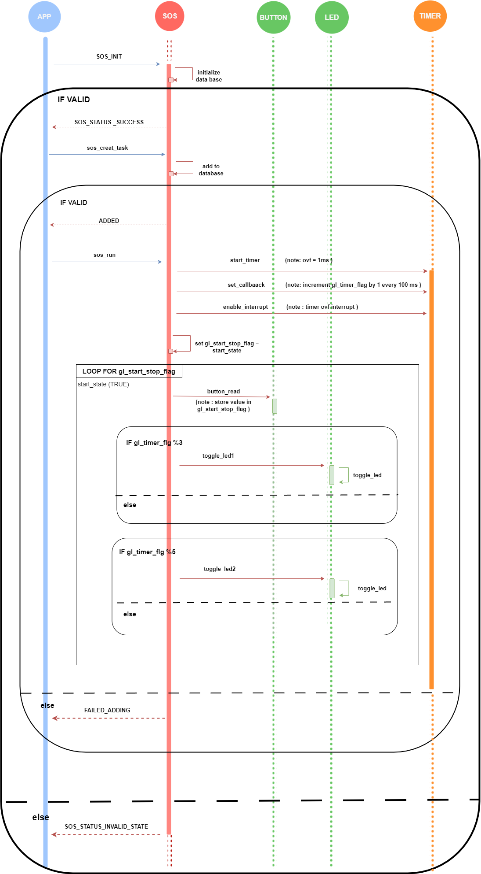



# STATE MACHINE